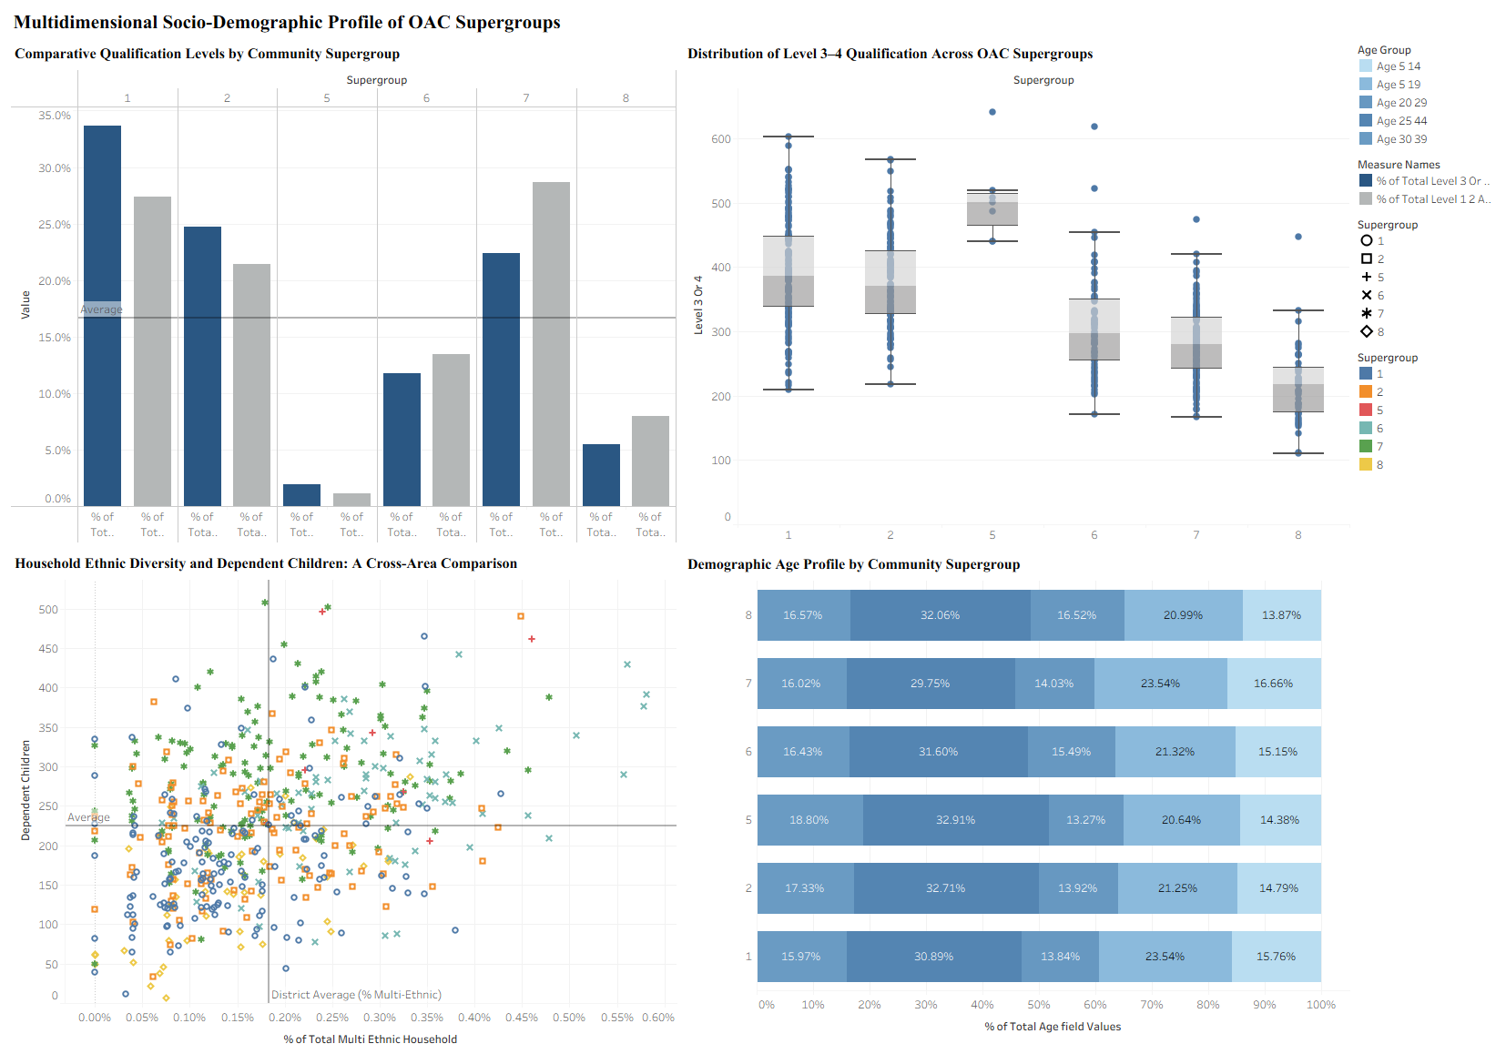

ESSAY
Message and Audience
By combining age distribution, educational attainment, ethnic diversity, and household composition, this visualization offers a multifaceted sociodemographic comparison of the 2021 OAC Supergroups. The main takeaway is that sociodemographic traits differ systematically among supergroups, with variations evident in internal variability and cross-variable relationships in addition to average levels. A policy-focused or analytical reader (such as local government planners) looking for a comprehensive, yet comprehensible summary of community structure is the target audience. Without referring to the essay that goes with it, the dashboard is exploratory but structured to highlight trends in educational attainment, demographic composition, and diversity–family structure relationships.
Encoding Choices
To encourage visual balance and a structured reading flow, the visualisation consists of four synchronised elements arranged in a two-by-two grid (Few, 2012). The 2021 OAC Supergroups serve as the main categorical data object for all components, guaranteeing uniformity across views and facilitating cross-chart comparison.
Level 3–4 and Level 1–2 qualification attainment is represented by vertical bars aligned along a common quantitative y-axis that represents the percentage of residents in the top-left grouped bar chart. Position on a common scale is used to represent magnitude, allowing for perceptually accurate comparison (Cleveland & McGill, 1984). The district average is indicated by a horizontal reference line, which offers contextual benchmarking. The subdued blue-grey colour scheme preserves graphical integrity and lessens superfluous visual emphasis (Tufte, 2001).
The distribution of Level 3–4 attainment at the OA level within each supergroup is shown in the boxplot at the bottom-right. By encoding median, interquartile range, whiskers, and outliers, standard boxplot conventions enable evaluation of internal variability and heterogeneity beyond central tendency. Semi-transparent jittered points preserve density and dispersion information while minimizing overplotting.
The relationship between dependent children (y-axis) and ethnic diversity (% multi-ethnic households, x-axis) is encoded in the bottom-left scatterplot. Quantitative association is represented by cartesian position, whereas colour hue is used to distinguish supergroup membership. Comparative analysis is supported by interpretive quadrants created by reference lines at district averages.
The age structure composition is shown in the top-right 100% stacked bar chart. A 0–100% horizontal scale is used to encode age bands as proportionate segments, allowing for structural comparison regardless of population size.
To maintain graphical integrity, the dashboard stays away from dual axes and truncated scales. To reinforce the analytical progression, the components are arranged from structural composition (top row) to variability and association (bottom row).
Critical Evaluation
The visualization's strengths are its coordinated multiple views, consistent colour scheme, and use of position-based encodings, which make it easier for people to see things accurately. Adding compositional, distributional, and relational representations makes analysis more in-depth. The dashboard, on the other hand, has a moderate amount of visual density when printed at A3 size, and the categorical colour coding in the scatterplot may make it harder for people who are colour-blind to use. The qualification bar chart is still more descriptive than the other parts that are more analytical. The design strikes a good balance between clarity, complexity, and graphical integrity while also allowing for structured exploratory interpretation.

